 | Department of Computer Science Faculty of Computing  UNIVERSITI TEKNOLOGI MALAYSIA

tm.my

COMMENTS:
SUBJECT NAME: | COMPUTER ORGANIZATION AND ARCHITECTURE
SUBJECT CODE: | SECR 1033
SEMESTER: | 2 - 2023/24
LAB TITLE: | Programming 1: Assembly Language Fundamentals
INSTRUCTION: | Student is required to have instructor’s signature before proceed from each lab work.
STUDENT INFO : | Name: Poh Lok Yee & Woo Cheng Shuan  Metric No: A23CS0262 & A23CS0283  Section: 02  Email: poh.yee@graduate.utm.my & wooshuan@graduate.u
SUBMITTED DATE: | 26/4/2024

Lab # 1
Simple program to familiarize with Program Code, Rebuild & Start Without Debugging

Execute the programs below:

PART 1:
- Part A: Adding and Subtracting Integers
TITLE Add and Subtract (AddSub.asm)
; This program adds and subtracts 32-bit integers
; Authors:
; Date:
; Revision:

INCLUDE Irvine32.inc

.data
TOTAL dword 0 ; a variable named TOTAL (declared as DWORD)

.code main PROC
mov eax, 123400h ; Set EAX with the value of 123400h add eax, 567800h ; Add the content of EAX with 567800h sub eax, 77700h ; Subtract content of EAX with 77700h mov TOTAL, eax ; Store content of EAX to TOTAL
call DumpRegs exit
main ENDP

END main
Experimental Results:
  - Rebuild & Start Without Debugging


Completed Fully Partially : Checked by:

Screenshot Result:
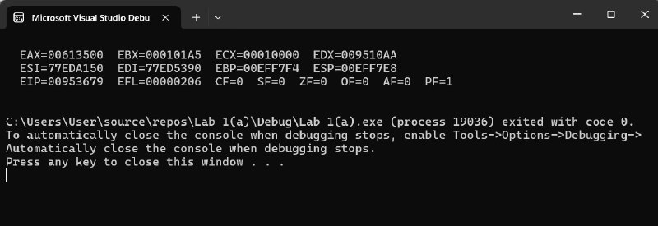

- Part B: Adding Variables
TITLE Add and Subtract, Version 2(AddSub2.asm)

; This program adds and subtracts 32-bit unsigned
; integers and stores the sum in a variable.
; Authors:
; Date:
; Revision:
INCLUDE Irvine32.inc
.data
val1 DWORD 10000h val2 DWORD 40000h val3 DWORD 20000h
finalVal DWORD ?
.code
main PROC mov eax,val1 add eax,val2 sub eax,val3
; start with 10000h
; add 40000h
; subtract 20000h
mov finalVal,eax ; store the result (30000h)
call DumpRegs
; display the registers
exit
main ENDP END main

Experimental Results:
  - Rebuild & Start Without Debugging


Completed Fully Partially : Checked by:

Screenshot Result:
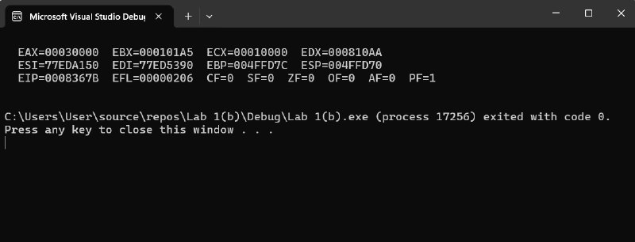

- Part C: Add and Subtract 8 and 16-Bit Version
TITLE Add and Subtract, Version 3
; This program adds and subtracts 8 and 16 bit
; unsigned integers and stores the sum in a variable.
; Authors:
; Date:
; Revision:

INCLUDE Irvine32.inc
.data
valw1 WORD 1000h valw2 WORD 4000h valw3 WORD 2000h finalValw WORD ?
valb1 BYTE 10h valb2 BYTE 40h valb3 BYTE 20h finalValb BYTE ?

.code main PROC
mov ax,valw1 ; start with 10000h add ax,valw2 ; add 40000h
sub ax,valw3 ; subtract 20000h
mov finalValw,ax ; store the result (30000h) call DumpRegs ; display the registers
mov ah,valb1 ; start with 10000h add ah,valb2 ; add 40000h
sub ah,valb3 ; subtract 20000h
mov finalValb,ah ; store the result (30000h) call DumpRegs ; display the registers
exit
main ENDP END main
Experimental Results:
  - Rebuild & Start Without Debugging


Completed Fully Partially : Checked by:

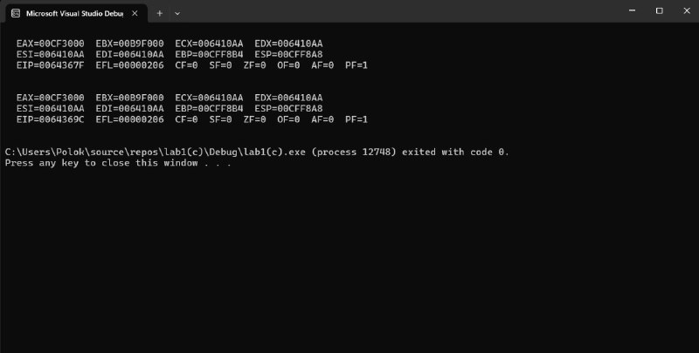
Screenshot Result:

Detail Debugging Process

PART 2:
Run Debugging Process for Part B, Part C and Capture Video

1. Press F10 for step by step debugging.
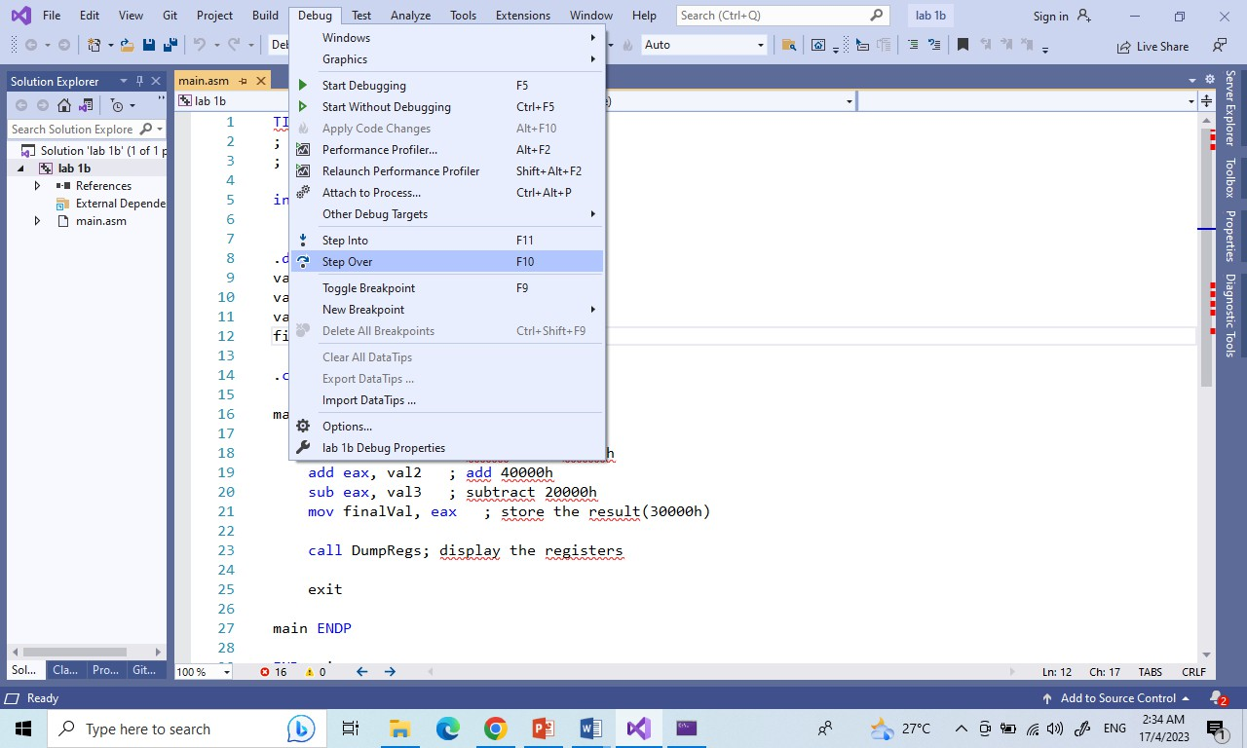
- Open 5 windows:
  - Watch
  - Autos
  - Memory
  - Registers
  - Disassembly

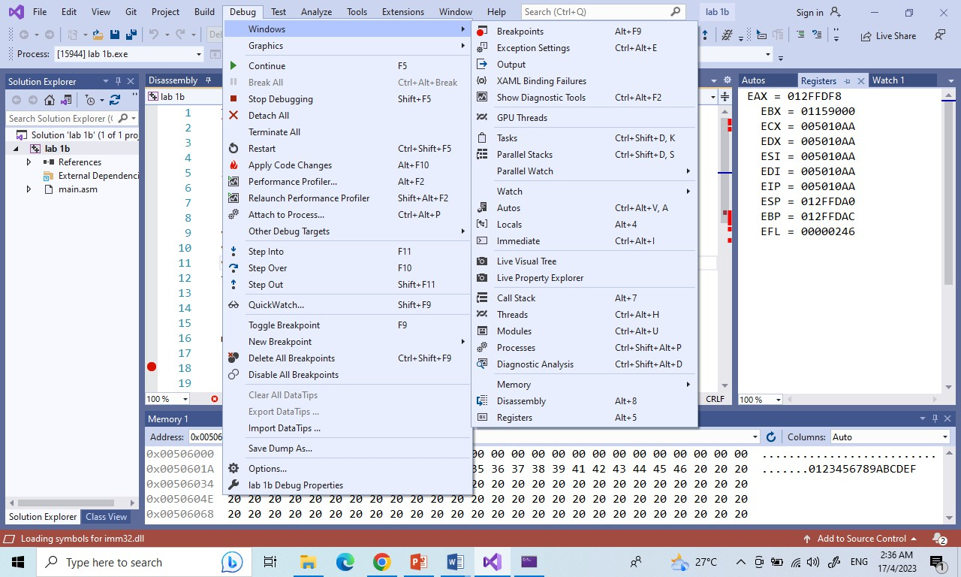

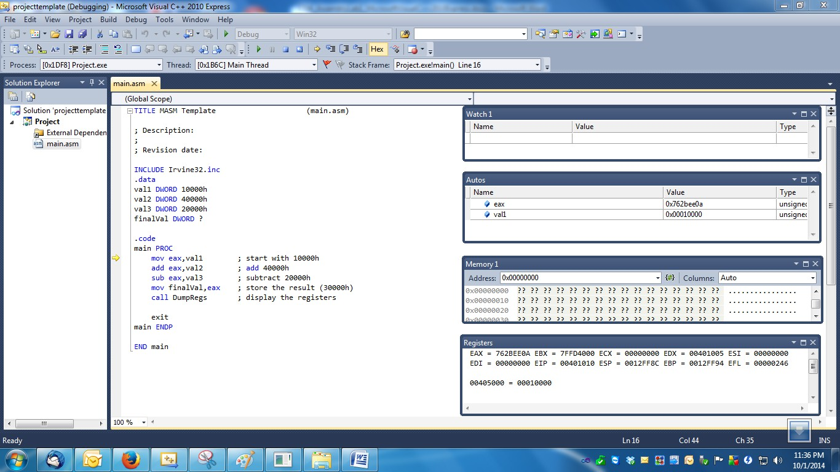
- Default memory data segment value is at first variable: &val1 or 0x00405000 (depend on memory used).
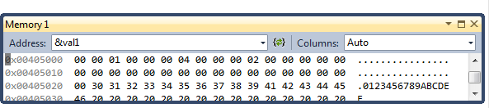
- Add variables val1, val2, val3 and finalval to Watch

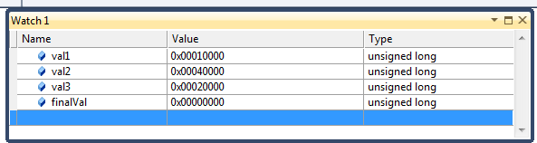

- F10 to trace/step the assembly program line by line.

- Please debug by looking at value changes at Watch, Memory, Autos and Registers windows.

- Disassembly window can show the following optional information:

- Memory address where each instruction is located. For native applications, it is the actual memory address. For Visual Basic or C#, it's an offset from the beginning of the function.
- Source code from which the assembly code derives.
- Code bytes, that is, the byte representations of the actual machine or MSIL instructions.
- Symbol names for the memory addresses.
- Line numbers corresponding to the source code.

What is Byte Code (or Machine Code) for the following assembly instructions:
mov ax,valw1 ; start with 10000h add ax,valw2 ; add 40000h
sub ax,valw3 ; subtract 20000h
mov finalValw,ax ; store the result (30000h)
Byte Code:
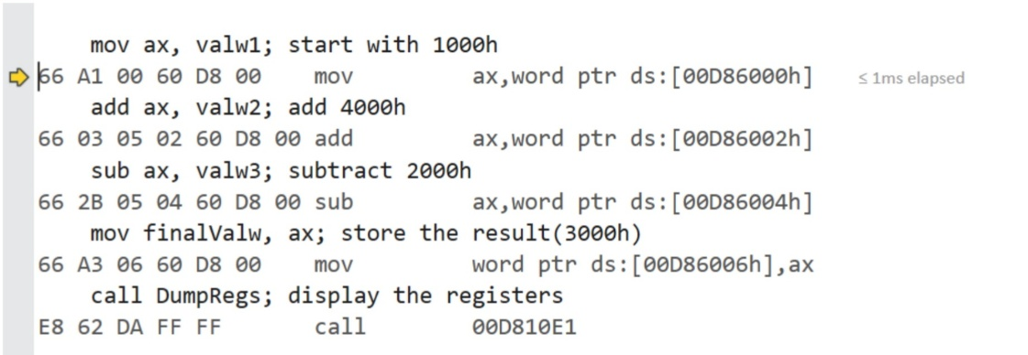

Experimental Results:
a) Rebuild & Start Debugging CamStudio:


Completed Fully Partially : Checked by:

Lab 1 Submission
Due: 6 May 2023 (Saturday: 23.59pm)

This is considering as a group submission. Each group requires ONLY 1 submission.

- Screen capture results part 1(a), (b), (c) - Start Without Debugging

- Code Submission

  - Zip both your exercise folders;
    - [ Lab 1a ]
    - [ Lab 1b ]
    - [ Lab 1c ]
  - Combine into ONE ( 1 ) zip file name "Lab1.zip".
  - Upload "Lab1.zip" file to e-learning under [ Labs Submission] section

- Prepare a video demo for debugging process Lab 1(b) and Lab 1(c) – Start Debugging. If your group consists of 3 students, must do Lab 1(a). Each student should explain one debugging process.

Requirement for the video:
  - Video duration is about 10 to 15 minutes
  - You MUST explain verbally on how you execute this Lab 1 in the video ( … show your face in recording, please 😊 )
  - The video can be recorded in any tools that you’re comfortable
    - Example; you may use any online meeting tool like Zoom, Google Meet, MS Teams to record your lab demo.

- Video Submission

Demo video can be submitted in two options:
- as an .mp4 video file (to be uploaded to e-learning) – this is not preferable if the size is big.

OR

- Upload your video to your YouTube account and share the YouTube video link in the submission option. Set your YouTube video unlisted video (i.e. only person whou has the link can see the video)
  - Upload OR share the YT video link to e-learning under [ Lab Submission] section.

Method (b) is the most preferable.

